**REPORT FOR BLOOD DONATION WEBSITE**

As a project work for course

**INTERNET PROGRAMMING LABORATRORY (CSE326)**

NAME :- MD. Tippu Ahamad

REGISTRATION NO :- 12214345

NAME :- D. SAI PAVAN KUMAR

REGISTRATION NO :- 12212392

NAME :- Muhammed Lifin PP

REGISTRATION NO :- 12220433

PROGRAMM :-CSE B.TECH

SEMISTER :-FIRST

SCHOOL :-SCHOOL OF COMPUTER SCIENCE AND ENGENEERING

UNIVERSITY :-LOVELY PROFESSIONAL UNIVERSITY

DATE OF SUBMISSION :-02ND DECEMBER 2022



LOVELY PROFESSIONAL UNIVERSITY, JALANDHAR,PUNJAB,INDIA

|  |  |
| --- | --- |
| 1. ABSTRACT   1.2 Acknowledgement |  |
| 1. INTRODUCTION    1. CONTEXT    2. MOTIVATION   2.3 IDEA |  |
| 1. TEAM MEMBERS WITH ROLES    1. MEMBERS   3.2 CONTRIBUTIONS |  |
| 1. code |  |
| 5. Screenshots |  |
| 6.About Blood Donation |  |
| 7. References |  |

**TABLE OF CONTENTS**

**BLOOD DONATION WEBSITE**

***1.ABSTRACT:-***

The purpose of this study was to develop a blood management information system to assist in the management of blood donor records and ease/or control the distribution of blood in various parts of the country basing on the hospital demands. Without quick and timely access to donor records, creating market strategies for blood donation, lobbying and sensitization of blood donors become very difficult.

The blood management information system offers functionalities to quick access to donor records collected from various parts of the country. It enables monitoring of the results and performance of the blood donation activity such that relevant and measurable objectives of the organization can be checked.

It provides to management timely, confidential and secure medical reports that facilitates planning and decision making and hence improved medical service delivery. The reports generated by the system give answers to most of the challenges management faces as far as blood donor records are concerned.

***1.1 ACKNOWLEDGEMENT:-***

I would like to thank my mentor – Geetika Sharma for her advice and inputs on this project. Many thanks to my friends and parents as well, who spent countless hours to listen and provide feedbacks.

**2.INTRODUCTION**

* 1. Context:-

This project has been done as part of my course for the CSE at Lovely professional university, supervised by Geethika Sharma.

* 1. Motivations

Being extremely interested in everything having a relation with the Machine Learning, the group project was a great occasion to give us the time to learn and confirm our interest for this field. The fact that we can check our blood donation website at an instant and later work in it .We can use programming almost everywhere. That’s why I decided to conduct my project into html.

* 1. Idea:-

As a first experience, we wanted to make my project as much didactic as possible by approaching every different steps of the python programming process and trying to understand them deeply. Known as ” toy problem” the problems that are not immediate scientific interest but useful to illustrate and practice, we chose to take house price Prediction as approach. The goal was to predict the price of a given house according to the market prices taking into account different “features” that will be developed in the following.

3.TEAM MEMBERS WITH ROLES:-

Member 1:-

Name :- MD. Tippu Ahamad

Contributions :-

1.Coding(joined)

2.Report

Member 2:-

Name :- D. Sai pavan kumar

Contribution :

1.coding for css

2.Report

Member 3:-

Name :-Muhammed Lifin PP

Conrtibutions :-

1.coding(joined)

2.report

**4.Code:-**

DOCTYPE html>

<html>

<head>

<style>

html{

scroll-behavior: smooth;

}

body{

background-color:#a7bbf8 ;

}

#navbar {

background-color: aqua;

position: fixed;

top:-50px;

width: 100%;

display: block;

transition: 0.3s;

}

#navbar a {

float: left;

display: block;

color: grey;

text-align: center;

padding: 15px;

text-decoration: none;

font-size: 17px;

}

#navbar a:hover {

background-color: #ddd;

color: black;

}

#title

{

text-align: left;

color:#f04c4b;

position: absolute;

top: 1cm;

left: 2cm;

font-size: 1cm;

font-family: 'Times New Roman', Times, serif;

}

.links{

display: inline;

margin:auto;

width: fit-content;

align-items: center;

text-align: center;

flex-direction: row;

}

#navbar >ul{

text-align: right;

list-style: none;

margin: 0%;

padding: 0%;

}

#navbar>li{

display: inline-block;

margin-left: 30px;

padding-right: 40px;

font-size: large;

}

#home{

color: pink;

}

#want{

padding-left: 5em;

color: #f04c4b;

}

.login{

margin: 0 auto;

padding: 0 auto;

text-align: right;

width: auto;

}

input[type=text], input[type=password]

{

border-radius: 18px;

width: 50%;

padding: 12px 20px;

margin: 8px 0;

display: inline-block;

border: 1px solid #ccc;

box-sizing: border-box;

}

button

{

border-radius: 18px;

background-color: #f04c4b;

color: white;

padding: 14px 20px;

margin: 8px 0 ;

border: none;

cursor: pointer;

width: 50%;

}

button:hover

{

opacity: 0.8;

}

#video{

height: 480px;

width: 720px;

padding-left: 30px;

}

#findd{

display: INLINE-block;

position:absolute;

top: 9CM;

left: 24cm;

width:10cm;

border-radius: 4px;

padding: 20px;

background-color: #f2f2f2;

text-align: center;

}

#WRITE{

padding-bottom: 10cm;

font-size: 0.5cm;

padding: 8px;

margin: 20px;

}

#WRITE > p{

padding: 20px;

}

#contactus{

text-align: center;

}

</style>

<script>

window.onscroll = function() {scrollFunction()};

function scrollFunction() {

if (document.body.scrollTop > 20 || document.documentElement.scrollTop > 20) {

document.getElementById("navbar").style.top = "0";

} else {

document.getElementById("navbar").style.top = "-50px";

}

}

</script>

</head>

<body>

<div id="navbar">

<ul class="links">

<li><a href="register.html">Register</a></li>

<li><a href="#WHYBLOOD">Why donate blood</a></li>

<li><a href="#whoblood">Who can give blood</a></li>

<li><a href="referafriend.html">Refer a friend</a></li>

<li><a href="#contactus">Conatct us</a></li>

</ul>

</div>

<div class="login">

<div id="title">

<a href="Blood bank project.html" style="text-decoration: none; color: #f04c4b;"><h1>LOVELY</h1></a>

<p id="SUbt">BLood Bank</p>

</div>

<form>

<br>

<label>Username</label>

<br>

<input class="Username"type="text" placeholder="Enter Username" required>

<br>

<label>Password</label>

<br>

<input type="password" placeholder="Enter Password" required>

<br>

<button type="submit">Login</button>

<br>

<span class="psw">Forgot <a href="#">password?</a></span>

<br>

<span class="psw">Don't have an <a href="register.html">Account?</a></span>

</form>

</div>

<hr>

<div id="samerow">

<div id="video">

<iframe width="560" height="315" src="https://www.youtube.com/embed/ezafVzfJw60" title="YouTube video player" frameborder="0" allow="accelerometer; autoplay; clipboard-write; encrypted-media; gyroscope; picture-in-picture" allowfullscreen></iframe></div>

<div id="findd">

<form>

<label>State</label>

<input type="text" required placeholder="Enter state">

<br>

<label>City</label>

<input type="text" required placeholder="Enter City">

<br>

<label>Area</label>

<input type="text" required placeholder="Enter Area">

<br>

<label>Blood type</label>

<select name="bloodtype">

<option value="A+">A+</option>

<option value="A-">A-</option>

<option value="B+">B+</option>

<option value="B-">B-</option>

<option value="AB+">AB+</option>

<option value="AB-">AB-</option>

<option value="O+">O+</option>

<option value="O-">O-</option>

</select>

<br>

<button type="search">Search</button>

</form>

</div>

</div>

<div ID="WRITE">

<div ID="WHYBLOOD">

<h1>ABOUT</h1>

<h2>Why Donate Blood</h2>

<p>A blood donation is truly an altruistic gift that an individual can give to others in need. In only 45-60 minutes, an eligible individual can donate one unit of blood that can be separated into four individual components that could help save multiple lives.</p>

</div>

<br>

<div id="whoblood">

<h2>Who Can Give Blood</h2>

<p>The criteria for donor selection varies from country to country, but blood can be donated by most people who are healthy and do not have an infection that can be transmitted through their blood.

The age at which people are eligible to give blood varies, but is commonly between the ages of 17 and 65. Some countries accept donations from people from the age of 16 and extend the upper age limit beyond 65 years.

Healthy adults can give blood regularly – at least twice a year. Your local blood service can tell you how frequently you can give blood.From one unit of blood, red blood cells can be extracted and used to treat patients who lost blood due to trauma or those who are recovering from surgery. Plasma, the liquid part of blood, is typically administered to patients with requiring treatment to improve blood clotting. Platelets, a third component, clot the blood when cuts or other open wounds occur, and are often used in the treatment of patients with cancer or those undergoing organ transplants. Finally, cryoprecipitated anti-hemophilic factor (AHF) is also used for clotting factors.</p>

</div>

<br>

<H2>What Is Blood Banking</H2>

<P>Blood banking is the process that takes place in the lab to make sure that donated blood, or blood products, are safe before they are used in blood transfusions and other medical procedures. Blood banking includes typing the blood for transfusion and testing for infectious diseases.</P>

<h2>Facts about blood banking</h2>

<p>

Facts about blood banking

According to the American Association of Blood Banks as of 2013:

</p>

<ul>

<li>About 36,000 units of blood are needed every day.</li>

<li>The number of blood units donated is about 13.6 million a year.</li>

<li>About 6.8 million volunteers are blood donors each year.</li>

<li>Each unit of blood is broken down into components, such as red blood cells, plasma, cryoprecipitated AHF, and platelets. One unit of whole blood, once it's separated, may be transfused to several patients, each with different needs.</li>

<li>Annually, more than 21 million blood components are transfused.</li>

</ul>

<div id="contactus">

<h3>To Contact Us</h3>

<p>Call us at:8764656987</p>

<p>Email: lifestream@bloodbank.org</p>

</div>

</body>

</html>

Code for Register :-

<!DOCTYPE html>

<html>

<head>

<title>REGISTER</title>

<style>

body {

font-family: Arial, Helvetica, sans-serif;

background-image: url("bgimg.jpg");

}

form {border: 3px solid #f1f1f1;}

#ppp

{

width: 35%;

position: absolute;

left: 13cm;

}

input[type=text], input[type=password] {

width: 100%;

padding: 12px 20px;

margin: 8px 0;

display: inline-block;

border: 1px solid #ccc;

box-sizing: border-box;

}

button {

background-color: #04AA6D;

color: white;

padding: 14px 20px;

margin: 8px 0;

border: none;

cursor: pointer;

width: 100%;

}

button:hover {

opacity: 0.8;

}

.cancelbtn {

width: auto;

padding: 10px 18px;

background-color: #f44336;

}

.imgcontainer {

text-align: center;

margin: 24px 0 12px 0;

}

img.avatar {

width: 40%;

border-radius: 50%;

}

.container {

padding: 16px;

}

span.psw {

float: right;

padding-top: 16px;

}

/* Change styles for span and cancel button on extra small screens */

@media screen and (max-width: 300px) {

span.psw {

display: block;

float: none;

}

.cancelbtn {

width: 100%;

}

}

</style>

</head>

<body>

<div id="ppp">

<h2>Register Form</h2>

<form action="/action_page.php" method="post">

<div class="imgcontainer">

<img src="img_avatar.png" alt="Avatar" class="avatar">

</div>

<div class="container">

<label for="fname"><b>First Name</b></label>

<input type="text" placeholder="Enter First Name" name="fname" required>

<label for="lname"><b>Last Name</b></label>

<input type="text" placeholder="Enter Last Name" name="lname" required>

<label for="uname"><b>Username</b></label>

<input type="text" placeholder="Enter Username" name="uname" required>

<label for="psw"><b>Password</b></label>

<input type="password" placeholder="Enter Password" name="psw" required>

<button type="submit">REGISTER</button>

<label>

<input type="checkbox" checked="checked" name="remember"> Remember me

</label>

</div>

<div class="container" style="background-color:#f1f1f1">

<a href="sideproject.html"><button type="button" class="cancelbtn">Cancel</button></a>

</div>

</form>

</div>

</body>

</html>

**5.Screenshots:-**

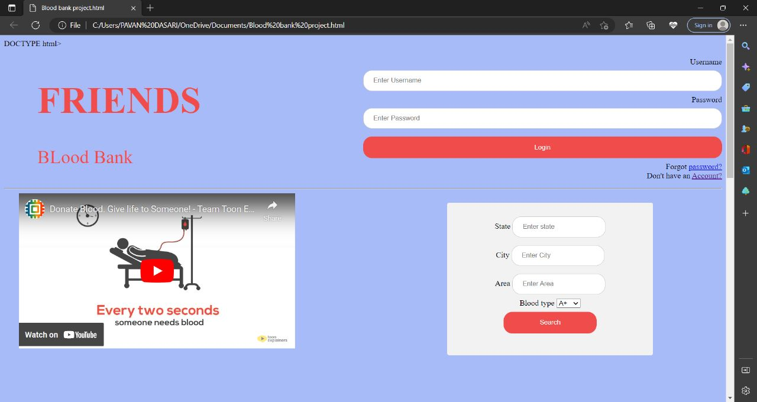

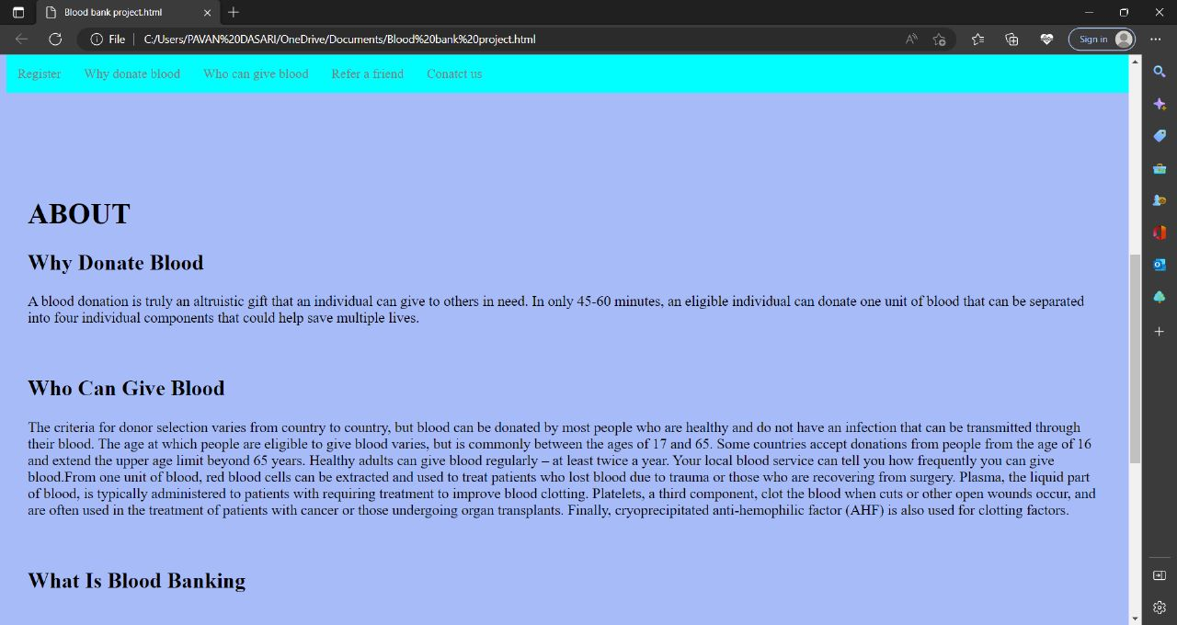

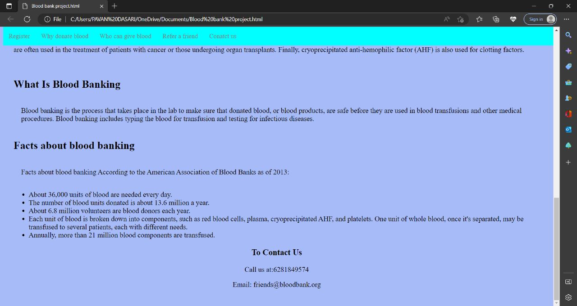

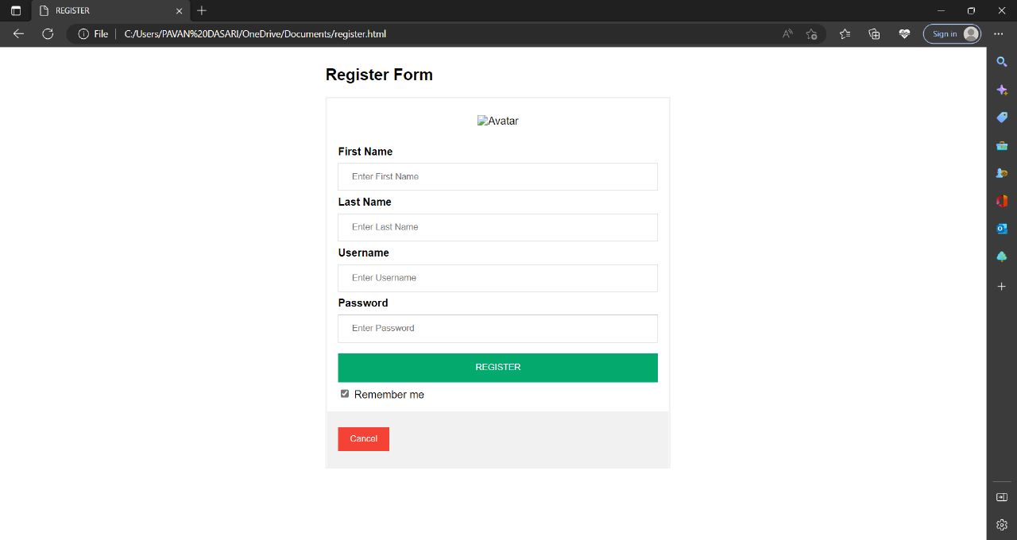

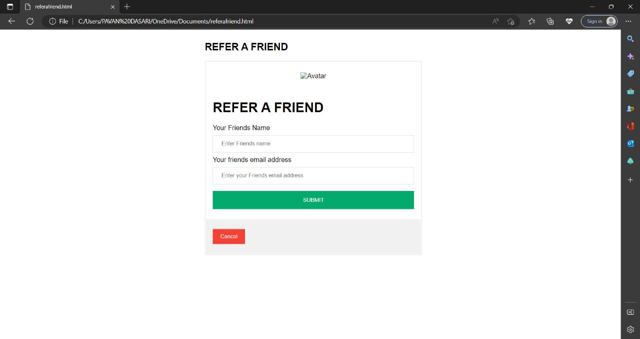

6.About Blood Donation:-

# Blood donation

"Give blood" redirects here. For other uses, see give blood.

"Blood donor" redirects here. For the TV episode, see [The Blood Donor](https://en.wikipedia.org/wiki/The_Blood_Donor).

A **blood donation** occurs when a person voluntarily has [blood](https://en.wikipedia.org/wiki/Blood) drawn and used for [transfusions](https://en.wikipedia.org/wiki/Blood_transfusion) and/or made into biopharmaceutical medications by a process called [fractionation](https://en.wikipedia.org/wiki/Blood_fractionation) (separation of [whole blood](https://en.wikipedia.org/wiki/Whole_blood) components). Donation may be of whole blood, or of specific components directly. [Blood banks](https://en.wikipedia.org/wiki/Blood_bank) often participate in the collection process as well as the procedures that follow it.

Today in the [developed world](https://en.wikipedia.org/wiki/Developed_world), most blood donors are unpaid volunteers who donate blood for a community supply. In some countries, established supplies are limited and donors usually give blood when family or friends need a transfusion (directed donation). Many donors donate for several reasons, such as a form of charity, general awareness regarding the demand for blood, increased confidence in oneself, helping a personal friend or relative, and social pressure. Despite the many reasons that people donate, not enough potential donors actively donate. However, this is reversed during disasters when blood donations increase, often creating an excess supply that will have to be later discarded. In countries that allow paid donation some people are paid, and in some cases there are incentives other than money such as [paid time off](https://en.wikipedia.org/wiki/Paid_time_off) from work. People can also have blood drawn for their own future. Donating is relatively safe, but some donors have bruising where the needle is inserted or may feel faint.

## The benefits of giving blood

1. **Giving blood can reveal potential health problems:-**

While it isn’t the same thing as a trip to the doctor, donating blood can be another way to keep an eye on your cardiovascular health. You’ll receive a mini-physical prior to the blood draw, in which someone will check your pulse, blood pressure, body temperature, hemoglobin and more.  This can sometimes shed light on issues you didn’t even know about.

“If your blood is too low in iron, the clinic will tell you and won’t draw your blood”, says Jan Patenaude, dietician and [certified LEAP therapist](http://certifiedleaptherapist.com/). They will also inform you of any other blood issues they notice or if anything seems unusual. An occasional check up on your blood quality could be the key to spotting a health issue before it becomes life-threatening.

### 2. Giving blood can reduce harmful iron stores

One in every two hundred people in the U.S. is affected by a condition called hemochromatosis and most don’t even know it, according to Patenaude. Hemochromatosis is a disease that causes an iron overload and is labeled as the most common genetic disease among Caucasians by the [Mayo Clinic](http://www.mayoclinic.org/diseases-conditions/hemochromatosis/basics/symptoms/con-20023606).

A committed blood donor herself, Patenaude recommends donation as a way to reduce the body’s extra iron stores. [The Centers for Disease Control and Prevention](https://stacks.cdc.gov/view/cdc/5763) says the removal of red blood cells by phlebotomy (or donating blood) is the preferred treatment for patients with excess iron in their blood.

### 3. Giving blood may lower your risk of suffering a heart attack

You might be surprised to discover that there may be [heart health](https://www.rasmussen.edu/degrees/health-sciences/blog/healthy-heart-tips/) benefits to giving blood. Donating blood at least once a year could reduce your risk of a heart attack by 88 percent, according to a [study conducted by the American Journal of Epidemiology](http://aje.oxfordjournals.org/content/148/5/445.full.pdf).* This relates to the iron issue again, says Dr. David Dragoo, healthcare expert at Money Crashers.

Dr. Dragoo explains that high levels of iron in the blood constrict your blood vessels and create more risk of a heart attack. Depleting those extra iron deposits by donating blood gives your vessels more room to operate.

### 4. Giving blood may reduce your risk of developing cancer

In an average, completely healthy person, the link between giving blood and decreased cancer risk is slim. But [research does support](https://well.blogs.nytimes.com/2012/08/13/a-host-of-ills-when-irons-out-of-balance/) a reduced risk of cancer for blood donors with different maladies, one of which is hemochromatosis.

Phlebotomy (the process of drawing blood) was found to be an iron-reduction method that is associated with lower cancer risk and mortality, according to a [study published by the Journal of the National Cancer Institute](https://academic.oup.com/jnci/article/100/14/996/917996). The study focused on patients affected by peripheral arterial disease (PAD), which the [Mayo Clinic](https://www.mayoclinic.org/diseases-conditions/peripheral-artery-disease/symptoms-causes/syc-20350557) describes as a common circulatory problem. PAD patients who regularly donated blood had a lower risk of developing cancer than those who did not.

### 5. Giving blood can help your liver stay healthy

Another danger of iron overload is the health of your liver. “In recent years, nonalcoholic fatty liver disease (NAFLD), the hepatic expression of metabolic syndrome, has reached epidemic proportions,” reports the [National Center for Biotechnology Information](https://www.ncbi.nlm.nih.gov/pmc/articles/PMC4922827/).

[Research has linked](https://www.ncbi.nlm.nih.gov/pmc/articles/PMC4922827/) too much iron with NAFLD, Hepatitis C and other liver diseases and infections. Though there are many other factors involved in these problems, donating blood can help relieve some of those iron stores and avoid extra issues in your liver.

### 6. Giving blood can help your mental state

While there are several physical benefits to donating blood, the most powerful health benefit is arguably in the psychological realm. Donating blood means that someone (or multiple people) somewhere will be getting the help they desperately need.

Donating blood, especially on a regular basis, can be similar to volunteer work. You give of your time (and your literal blood) to help strangers in need. If you go to specific blood donation location each time, you’ll get to know some of the staff who are also dedicating themselves to the cause of saving lives.

This kind of regular, altruistic interaction has major [psychological benefits](http://journals.lww.com/asaiojournal/Abstract/2001/01000/Altruism_and_the_Volunteer__Psychological_Benefits.2.aspx). Getting out of your usual environment to do something good for someone else is stimulating in the best kind of way.  Volunteering has been shown to have [positive effects on happiness](http://www.sciencedirect.com/science/article/pii/S0277953608000373). In people over 65-years-old, volunteering also [reduces the risk of depression](http://www.sciencedirect.com/science/article/pii/S0277953602000254) and loneliness.

Patenaude believes the psychological health benefit you receive from knowing you’re helping others is just as helpful as the physical health benefit. When you roll up your sleeve and sit down in that chair, you know you’re making a difference—and that makes you feel good!

## Blood donation benefits everyone

The health benefits of donating blood are considerable—but of course, the most important part of the process is helping to save lives. Donating blood is good for you, and it’s even better for all the people who desperately need the help.

If you don’t mind blood draws or the sight of blood, you might want to consider becoming a medical assistant. These professionals save lives every day just by doing their jobs.

***REFRENCES:-***

We have used different websites during our project here are some references to that.

1. Wikipedia

2. GeeksForGeeks https://www.geeksforgeeks.org/

3.w3 schools.org